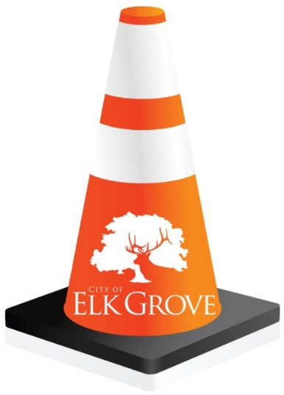
TRAFFIC ADVISORY

Contact:
Kristyn Nelson
Public Affairs Manager
916.478.2206 (Office)

For Immediate Release
May 30, 2019

Traffic Advisory: Elk Grove Festa Parade
Sunday Afternoon Street Closure for 52nd annual Celebration of the Holy Spirit

Elk Grove, CA – The City of Elk Grove will implement temporary traffic controls along East Stockton Boulevard on Sunday, June 2 for the 52nd annual Celebration of the Holy Spirit hosted by the Portuguese Fraternal Society of America (PFSA). This traditional celebration includes a parade starting at the SES Hall located at 10428 East Stockton Boulevard that will travel along East Stockton Boulevard to Union Park Way and back to the SES Hall.

Traffic Delays & Detours: A traffic plan has been created and road closures and detours will be in effect from approximately 12:00 p.m. to 1:30 p.m. East Stockton Boulevard will be closed in both directions between Hampton Oak Drive and Grant Line Road.
Alternative Routes: Motorists attempting to travel to destinations north or south should use Waterman Road or West Stockton Boulevard during the closure. Residents, churches, and businesses in proximity to the closure should expect delays.
For questions or concerns before or during the event, please contact Elizabeth Ward, PFSA Parade Marshall at (916) 496-0692.

Street Use Permit #19-01423

# # #

